ひづけ | がつ にち ようび |  | なまえ

 |  |  | ら |  |  | ●
 |  |  | ●
と | ● |  |  |  |  | ●
 |  |  | ●
 |  |  | り |  |  | ●

ひづけ | がつ にち ようび |  | なまえ

 |  |  | ね |  |  | ● | 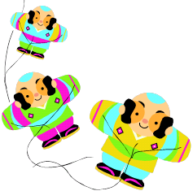
 |  |  | ●
た | ● |  |  |  |  | ●
 |  |  | ●
 |  |  | こ |  |  | ●

ひづけ | がつ にち ようび |  | なまえ

 |  |  | じ |  |  | ● | 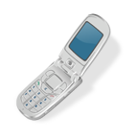
 |  |  | ●
ね | ● |  |  |  |  | ●
 |  |  | ●
 |  |  | こ |  |  | ●

ひづけ | がつ にち ようび |  | なまえ

 |  |  | く |  |  | ● | 
 |  |  | ●
に | ● |  |  |  |  | ●
 |  |  | ●
 |  |  | じ |  |  | ●

ひづけ | がつ にち ようび |  | なまえ

 |  |  | ん |  |  | ● | 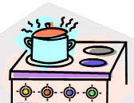
 |  |  | ●
も | ● |  |  |  |  | ●
 |  |  | ●
 |  |  | ち |  |  | ●

